# Competitor analysis

## Competitor Profile (Justanswer)

### Overview

We will be analyzing a potential competitor called Just Answer, which offers on demand experts to answer your questions. Talk to a doctor, vet, financial advisor and more in minutes. URL: [www.justanswer.com](http://www.justanswer.com)

### Key Objective

Just Answer’s mission is to make doctors, lawyers, vets, mechanics, and other verified Experts accessible to anyone, anywhere, at any time, and on any budget. The company is leading the democratization of professional services, empowering people with real-time access to affordable assistance, insight, and expertise—24/7.

### Overall Strategy

Just Answer positioned themselves against other companies in their industry by launching an AI chatbot that answers simple questions, helps qualify leads and more effectively connects its customers with one of the site's experts. AI brings greater intelligence and efficiency to the process, resulting in better close rates, a higher percentage of paying customers and a better customer experience. Press does seem to be an outlet for promotion, their latest article was written in May 2018. The company is using a unique algorithm that is verifying the quality of each expert. JustAnswer pays their experts earnings of 20% of what the user is willing to pay for the answer if it is accepted. The experts can work up to earning 50%. The experts can cash out to PayPal. Each question varies in the amount it pays, but the average appears to be $20. Just Answer maintains a 3.3 -star rating on the Apple app store out of 4.5k ratings, and a 3.0 star rating on the Google Play app store out of 331 overall ratings[1]

### Bottom Line

* + JustAnswer falls in the category of professional services, advice, customer service, Q&A marketplace
  + Small growth in google play store
  + Could spend more on marketing but they may be trying to improve the product experience, AI, and algorithms first
  + On a mission to help people.

### Strengths

* + Rigorous 8-Step Expert Quality Process
  + Unique algorithm that verifies the quality of each expert
  + AI chatbot provides greater intelligence and efficiency to the process
  + High 4.3 rating in bbb.org and consumer affairs

### Opportunities

* Build a delightful user experience with the app where users can explore experts by categories and empowering them to connect with experts of their choosing. Enabling users of the app to choose between communicating by voice, video or texting with Experts.
* Add a search feature to the app
* The website feels like they are trying to pitch and sell something to us.

### Weaknesses

* Mobile app is a limited extension of their website
* Charging users when they have not received answers
* Customer service needs improvement
* Poor organic search
* No button to sign up on the home page for users looking to go through
* an on-boarding flow.

### Threats

* Quora
* Industry specific expert marketplaces
* ADA

## UX Analysis

### Usability

Just Answer’s iOS App is following Apple’s guidelines and using basic iOS components which makes it easier to use. The apps main feature is to ask a question, but we would like to be able to search and review experts’ profiles. The app is a limited extension of their website. Their color palette fails to meet standard usability compliance, we would recommend selecting brand colors that meet WCAG AA compliance(“Web Content Accessibility Guidelines (WCAG) Overview | Web Accessibility Initiative (WAI) | W3C,” n.d.), to avoid becoming a disability discrimination litigation target.

### Navigation Structure

Menu is easy find on the bottom navigation. It does not make sense that “My Questions” bottom nav tab lands on “Favorite Experts” segmented control by default. Shouldn’t “My Questions” be the default? The home button nav tab, I believe should be titled “Home” instead of “My Questions.”

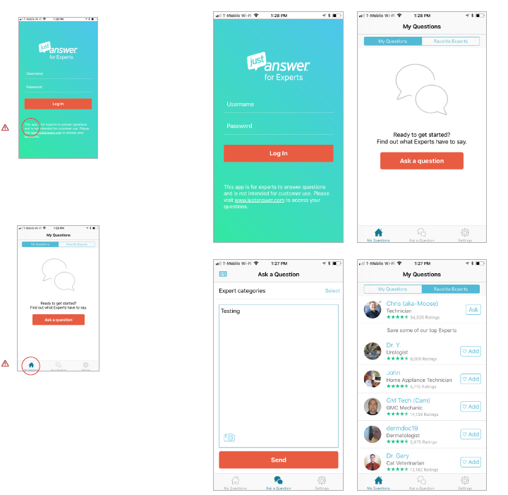

## IOS SCREENSHOTS

## Competitor Profile (ADA Health)

### Overview

We along with just answers we will be analysing a potential competitor called Ada health, Ada Health GmbH is a company based in Berlin which operates Ada, a symptom checker app. url: <https://ada.com>

### Key Objective

Ada is a global health company founded by doctors, scientists, and industry pioneers to create new possibilities for personal health. Ada’s core system connects medical knowledge with intelligent technology to help all people actively manage their health and medical professionals to deliver effective care

### Overall Strategy

The app started out as a platform service for doctors and was adapted in 2016 to focus on the bits patients could understand. The app takes reported symptoms, matches them with symptoms of patients of similar age and gender, and reports the statistical likelihood that the patient has a certain condition. The detailed report, compiled by Ada, can be sent to a doctor as a PDF. The Ada Health app is designed to give better information than you would get from Google results. Users open the free app, enter their age and gender, and type in a symptom like pain or a cough. Then a bot powered by machine learning asks several basic questions, such as how long the symptom has persisted, what makes it worse, and whether any related symptoms have popped up. (“Ada Health app lets you type in symptoms and learn possible ailment - Business Insider,” n.d.) Ada Health maintains a 4.4 -star rating on the Apple app store out of 2.3K ratings, and a 4.5k star rating on the Google Play app store out of 500k overall ratings[2]

### Bottom Line

* Ada health falls in the category of healthcare applications
* Massive growth in google play store
* Could spend more on marketing but they may be trying to improve the product experience, AI, and algorithms first
* On a mission to reduce visit to doctor despite initially being developed for doctors.

### Strengths

* Ada Health received funding from William Tunstall-Pedoe, the AI entrepreneur behind Amazon's Alexa, as well as Google’s chief business officer Philipp Schindler. The company has raised $69.3 million since it was founded in 2011.
* AI chatbot provides greater intelligence and efficiency to the process
* Immense user response

### Weaknesses

* No web application based interface
* Customer service needs improvement
* Poor organic search
* an on-boarding flow.
* Lots of false positives in the suggestions
* Number of Questions and Duration - To find a solution, the app had to ask an average of 34 questions per case (mean 33.78, SD 8.73) about the type and duration of the symptoms.
* The average time to find a solution was 409 seconds (SD 141.23)
* A research by (Jain, Agrawal, Goyal, & Aggrawal, 2018)(Jungmann, Klan, Kuhn, & Jungmann, 2019) proved that diagnostic quality was lower among users from the general population and students perspective.
* A key component of bot design is personality, something which Ada appears to be severely lacking. Interactions with Ada are dry and sterile.

## UX Analysis

### Usability

Ada health is easy to use as compared to other applications like zocdoc, medbot, just answer, Quora, etc. available online. Their color palette also fails to meet standard usability compliance similar to justanswer. Ada doesn’t really make much of an effort to make diagnosis more human. The descriptions are still quite verbose and jargon-based. The menu screen, although we liked it, apparently the use of hamburger icons at the bottom right to bring about menus is a design no-no. Mainly because they lack clarity and people rarely click on them. A possible alternative could be using a (+) button instead. Personality can be key. In most cases you are not trying to create a faceless utility, you want interactions to be memorable and fun. Giving your app/bot an interesting personality can do that.

### Navigation Structure

Navigating till the end of prediction is a bit of task as Ada asks almost 30 – 40 questions which can be very disturbing for a person who wishes to diagnose themselves or others. There are good things as well, it gives an option to the user to select the range of their ailment ranging from low to mild to severe. Also allows users to view their past diagnoses as well

## Android Screenshots

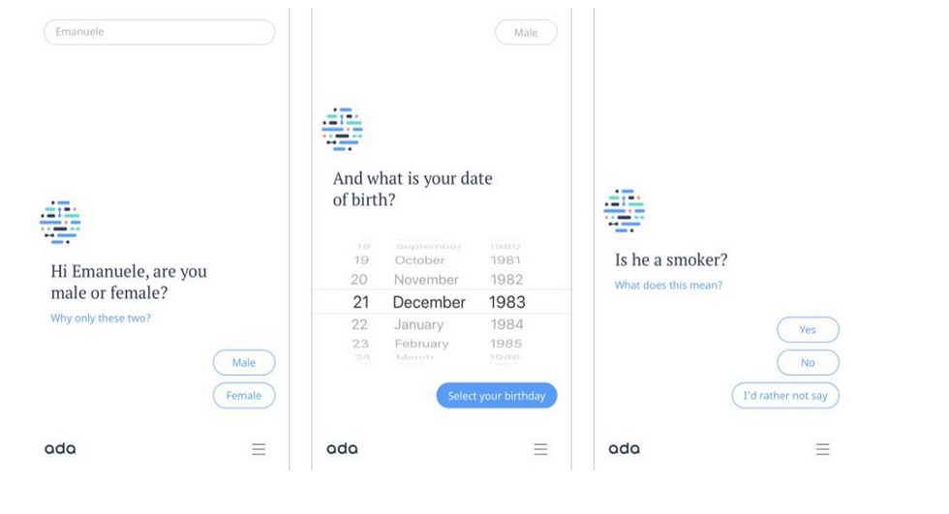

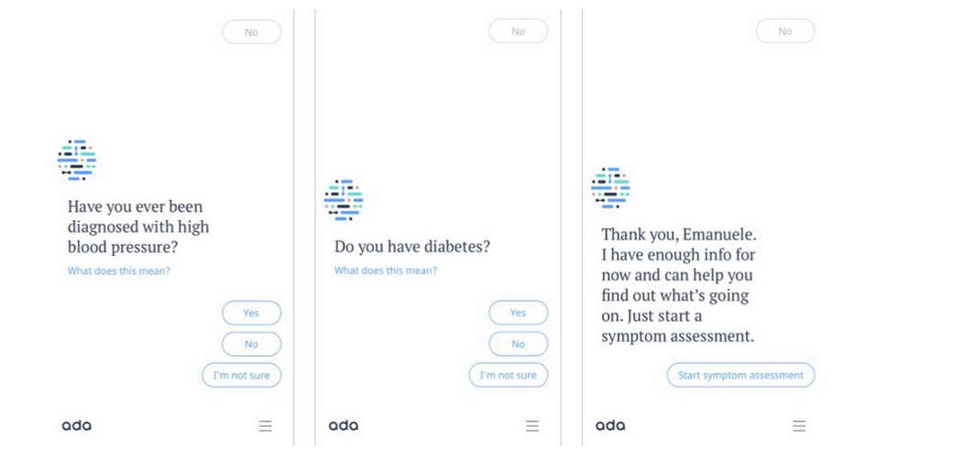

# References

Ada Health app lets you type in symptoms and learn possible ailment - Business Insider. (n.d.). Retrieved October 6, 2020, from https://www.businessinsider.com/health-startup-alternative-to-googling-symptoms-2018-8?IR=T

Jain, T., Agrawal, N., Goyal, G., & Aggrawal, N. (2018). Sarcasm detection of tweets: A comparative study. *2017 10th International Conference on Contemporary Computing, IC3 2017*, *2018*-*Janua*(August), 1–6. https://doi.org/10.1109/IC3.2017.8284317

Jungmann, S. M., Klan, T., Kuhn, S., & Jungmann, F. (2019). Accuracy of a Chatbot (Ada) in the Diagnosis of Mental Disorders: Comparative Case Study With Lay and Expert Users. *JMIR Formative Research*, *3*(4), e13863. https://doi.org/10.2196/13863

Web Content Accessibility Guidelines (WCAG) Overview | Web Accessibility Initiative (WAI) | W3C. (n.d.). Retrieved October 6, 2020, from https://www.w3.org/WAI/standards-guidelines/wcag/

1. As of Date 06th October 2020
2. As of Date 06th October 2020